**How to Install WordPress Ubuntu Using LAMP Stack**

**WordPress** is a powerful, free, and open-source, highly pluggable, and customizable CMS that is being used by millions around the world to run blogs and fully functional websites.

### Install LAMP Stack on Ubuntu Server

#### Step 1: Install Apache Web Server on Ubuntu

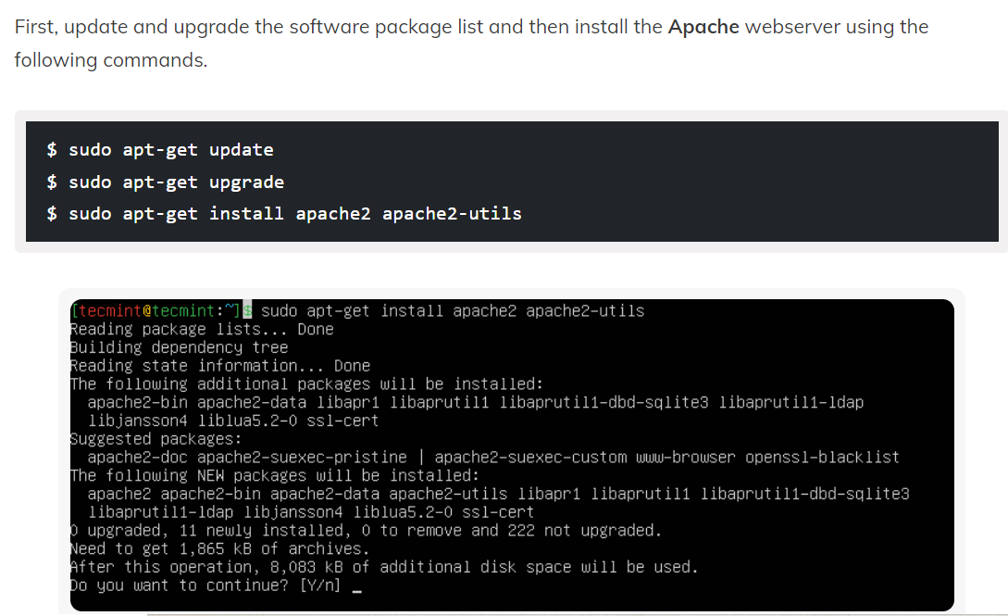

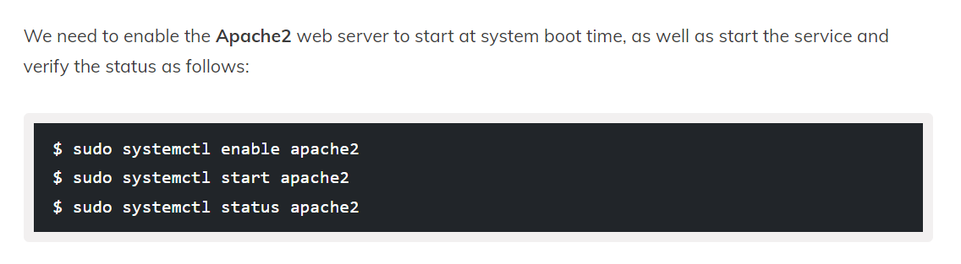

#### **Note**: The Apache default root directory is **/var/www/html**, all your web files will be stored in this directory.

#### Step 2: Install MySQL Database Server

#### Step 3: Install PHP in Ubuntu

#### Step 4: Install WordPress in Ubuntu

#### Step 5: Create WordPress Database

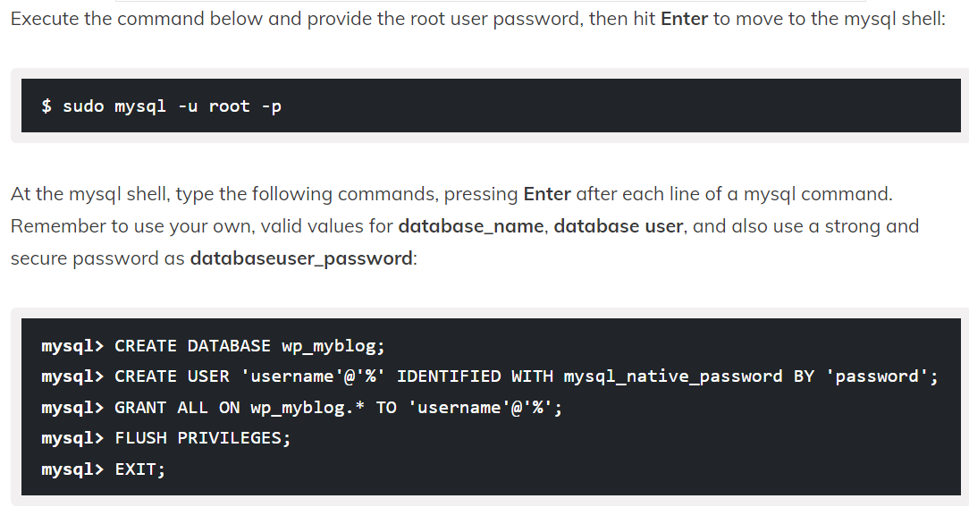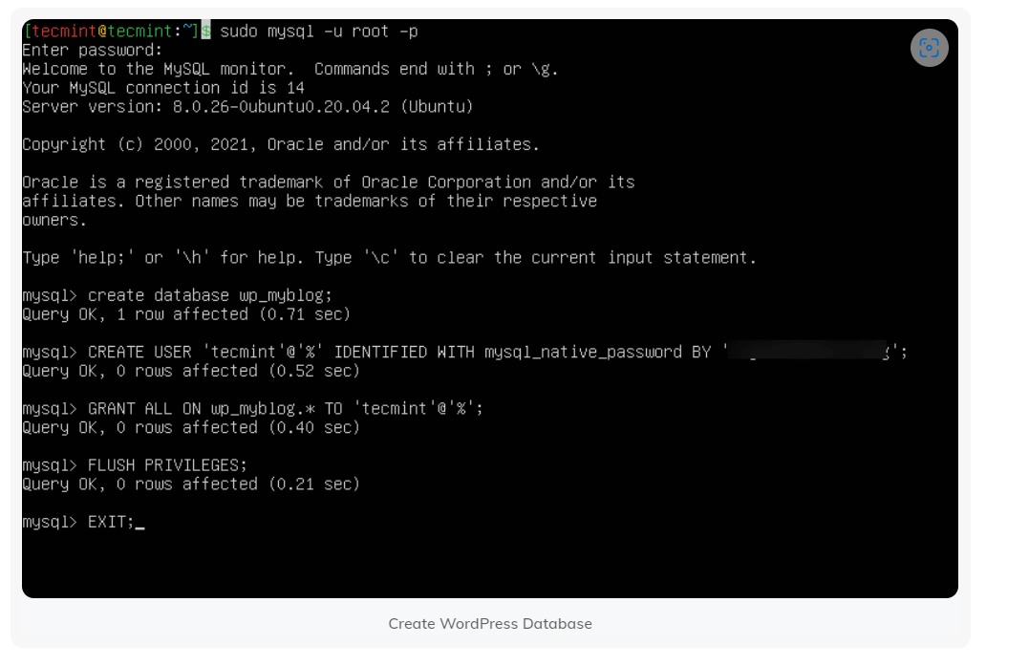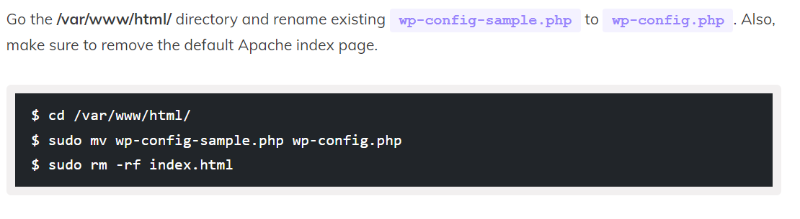Then update it with your database information under the MySQL settings section (refer to the highlighted boxes in the image below): 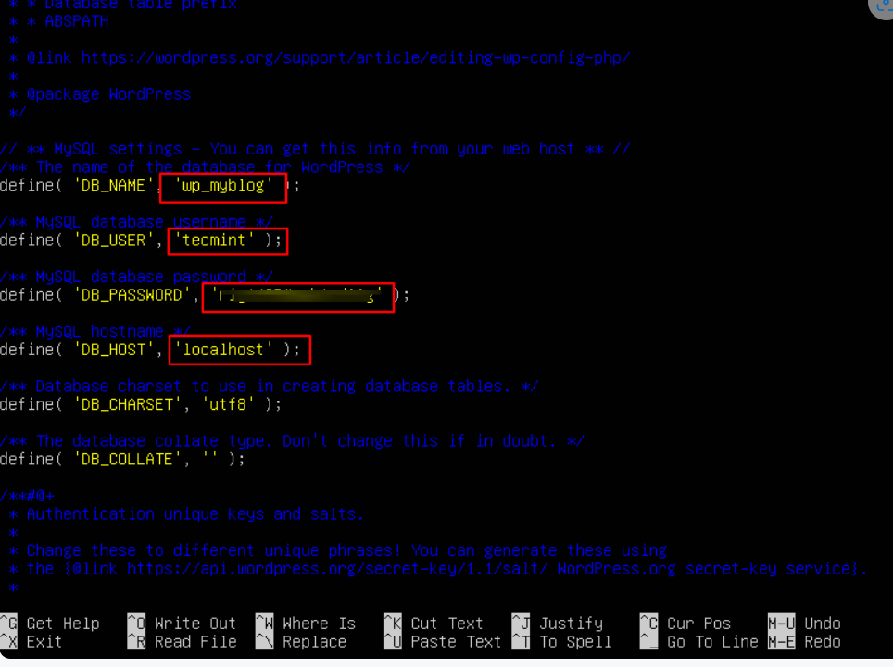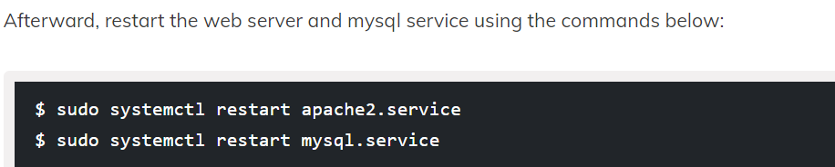Open your web browser, then enter your domain name or server address as shown. 